MANAGEMENT SYSTEM FOR A RESTAURANT
By
ZAHA ASHFAQ
BSSE, FACULTY OF INFORMATION AND TECHNOLOGY(FCIT), 2024

WEB-ENGINEERING SEMESTER PROJECT

Submitted To SIR SHUJA



ABSTRACT

The Management System for a Restaurant is a web application allowing customers to order online by choosing their favorite food items from the restaurant's menu. This website's user-friendly layout organizes a variety of food items.

Customers can order food courses and items online and pick them up nearby. This web application consists of a database that stores information about customers, the food menu, and inventory. This application provides a feasible way for owners to order inventory. Customers can plan their visit, ensuring they have a reserved spot, especially during peak hours.

The motive for designing this web application is to encourage the cloud kitchen concept. Nowadays, most customers are attracted to ordering food online, which is more convenient. Due to this transition, restaurants must provide online services to recover from their past financial crises. Customers and restaurants benefit equally from it.

This application has the scope of enhancing the existing application in terms of performance, efficiency, and an effective user interface by using the Model-View-Controller (MVC) framework and bootstrap technologies.

Table of Content

WEB-ENGINEERING SEMESTER PROJECT 1
1 Project Description 5
1.1 Competitive Information 5
1.2 Definitions and Acronyms 5
1.3 Future Enhancements 5
2 Project Technical Description 6
2.1 Application Architecture 6
2.2 Project Objectives 8
3 Code Details: 8
3.1 Main Controller: 8
3.1.1 Action Methods: 8
3.1.2 Views(For main controller): 9
Layout: 9
Body Section: 9
Spinner for Loading 9
Navbar 9
Offcanvas for Reservations: 10
Offcanvas for Navigation: 10
<main> Section: 10
Footer Section (JavaScript) 10
Index View 11
Main Section (Carousel) 11
About Section 11
After-Before Section(Cards Section) 12
Explore Our Menu 12
Get in Touch 13
Book the Table 13
Sign Up Section 14
Scripts 14
3.2 Menu Controller: 14
3.2.1 Action Methods: 14
3.2.2 Views(For Menu Controller): 15
ViewMenu View 15
Navigation Bar: 15
Header Section 15
Menu Section with Scrollspy: 16
Search Bar: 16
Footer Section: 16
3.3 Cart Controller 17
3.3.1 Action Methods 17
AddToCart (POST) 17
ViewCart (GET) 17
ClearCart (GET) 17
RemoveFromCart (POST) 18
Checkout (GET) 18
Checkout (POST) 18
OrderConfirmation (GET) 18
3.3.2 Views(For Cart Controller): 19
ViewCart View: 19
OrderConfirmation View: 21
CheckOut View: 21
3.4 Reservation Controller : 22
3.4.1 Action Methods: 22
AvailableTables 22
ReserveTable (POST) 23
Behavior 23
Redirect 23
3.4.2 Views(For Reservation Controller) 23
AvailableTables View: 23
ReservationConfirmation View: 24
3.5 Account Controller 25
3.5.1 Action Methods 25
Login (GET) 25
Login (POST) 25
AdminDashboard (GET) 26
CustomerDashboard (GET) 26
Register (GET) 26
Register (POST) 26
ForgotPassword (GET) 27
ForgotPassword (POST) 27
Logout 27
3.5.2 Views(For Account Controller): 28
Login View: 28
Register View: 28
ForgotPassword View: 29
AdminDashboard View: 30
3.6 Admin Controller 30
3.6.1 Action Methods: 30
ViewOrders 30
ManageUsers 30
EditUser (GET) 31
EditUser (POST) 31
DeleteUser (GET) 31
DeleteUserConfirmed (POST) 31
ViewReports 31
ManageProduct 31
EditProduct (GET) 32
EditProduct (POST) 32
DeleteProduct (GET) 32
DeleteConfirmed (POST) 32
AddProduct (GET) 32
AddProduct (POST) 32
EditTables 32
EditTable (GET) 33
EditTable (POST) 33
ViewReservation 33
CancelReservation 33
3.6.2 Views(For Admin Controller): 33
AddProduct View: 34
DeleteProduct View: 35
DeleteUser View: 36
EditProduct View: 37
EditTable View: 39
ViewReservation View: 41
THE END 42

1 Project Description

The Management System for a Restaurant web application assists customers in ordering their favorite food items online by navigating to the website's food menu and categories. This application mainly consists of two roles, admin, and customer. The restaurant menu is available for all customers to browse on the website. Customers need to be authenticated whenever they try to add an item to the cart or register as new customers. Once the customer has logged into the website, they will add, modify, or delete the food items in the cart, and place an order. Administrators, who are usually restaurant owners, will accept the order and give regular updates about the order's status to the customer. A user with admin privileges can also modify orders, food items, and inventory. Admins can also view the weekly report, manage ordered items, and manage table reservation details.

1.1 Competitive Information

Like many other food ordering systems, our application stands out among others in terms of design specifications and user interface. This application allows users to easily navigate food menus based on categories and displays warning messages wherever necessary in a pleasant manner.

1.2 Definitions and Acronyms

UI – User Interface.

Viz – Visualization
.
UX – User Experience.

ASP – Active Server Pages.

MVC – Model-View-Controller.

ORM – Object Relational Mapping

1.3 Future Enhancements

In the future, this application can be enhanced in an effective way by improving user-friendly functionality with advanced filters and UX improvements. We are planning to introduce live delivery tracking of orders by integrating with the Google Maps API and a payment gateway for successful money transactions.
.

2 Project Technical Description
This project comprises two main modules: Admin and Customer. The objective of this project is to deliver a customer-friendly web application so that customers can easily navigate between website links to create an online order.

2.1 Application Architecture
This Application was developed based on two main frameworks, Model-View-Controller and Entity Core framework [1],[2],[3].

Model-View-Controller (MVC)
MVC generally divides web applications into three parts: Model, View, and Controllers. The end user will initially send a request to the server, and then the controller will handle the request and pass it on to the model. After interacting with the database and performing some functionality, the model will then fetch the data from the table and return it to the controller. The controller will then send the data to the view. View will format the data, and this formatted data will be displayed to the client [1]
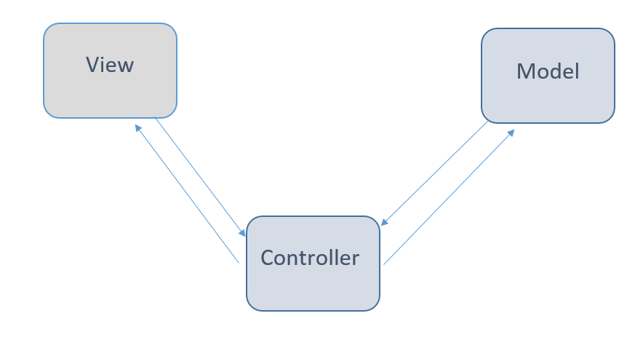
Below you can see the project directories categorized according to the MVC framework.

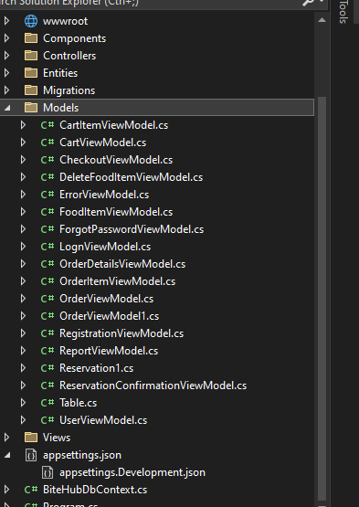
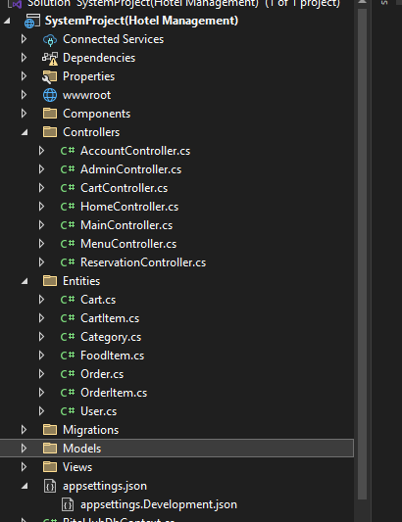
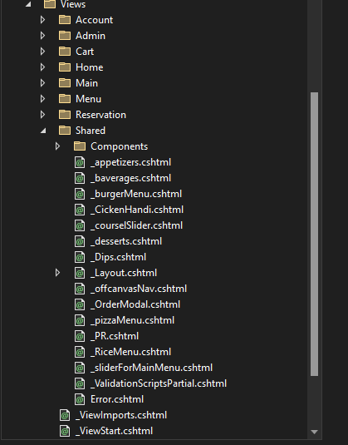

Entity Core Framework
For reading and managing data in databases, we use Entity Framework Core (EF Core), which is an object-relational mapping (ORM) framework that is lightweight and cross-platform [3]. EF Core supports both the code-first and data-first approaches. This project follows the Code First approach, where we will design our application domain classes and a special class that is derived from the entity framework DB context class. EF Core will create the database and the relevant tables
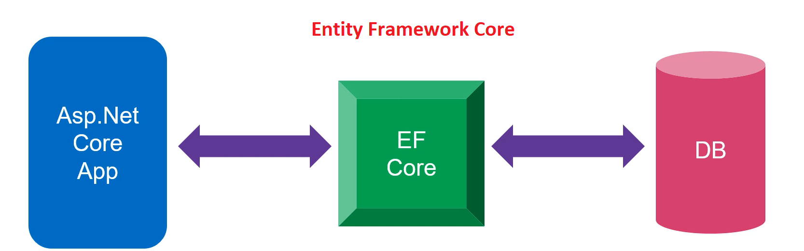

2.2 Project Objectives
- Food Delivery Management: Enable users to order food and track deliveries within the hotel.
- Reservation System: Allow customers to book tables easily and manage these bookings efficiently.
- Monthly Analytics: Provide actionable insights through detailed analytics on sales, customer behavior, table occupancy, and other key metrics.
- Admin and User Layouts: Separate dashboards for admins and users to enhance usability and experience.

3 Code Details:

3.1 Main Controller:
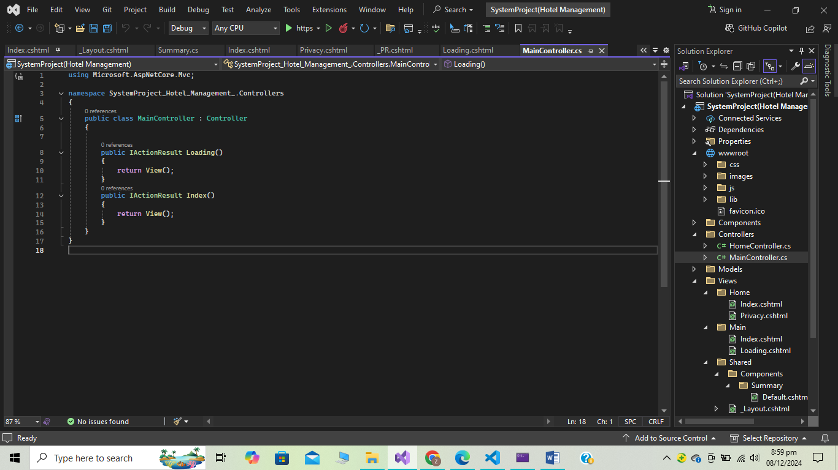
Class Definition: MainController is a class derived from Controller which provides the necessary methods to handle web requests and responses.

3.1.1 Action Methods:
  - Loading(): This method returns the Loading view. It's used to display a loading page before redirecting to the website's main content.
  - Index(): This method returns the Index view. It's the page the user is redirected to after the loading screen finishes.

3.1.2 Views(For main controller):

Layout:
The page uses a shared layout file (_Layout.cshtml), which is commonly used across multiple views. This layout typically contains common elements like headers, footers, and navigation links. By using this layout, the page inherits a consistent structure with other pages in the project.
In _Layout. cshtml:

Body Section:

Spinner for Loading
- Purpose: A spinner is displayed at the center of the page to indicate that content is loading.
- Structure:
  - The spinner is wrapped in a div with the class d-flex justify-content-center to center the spinner both horizontally and vertically.
  - The spinner itself is a div with the class spinner-border, which creates the spinning animation. It has the attribute role="status" to communicate its purpose to screen readers, and the text “Loading…” is visually hidden using the visually-hidden class, ensuring accessibility for users with screen readers.
- JavaScript: A small JavaScript snippet is included to show and hide the spinner. The spinner is initially visible, and after a timeout of 2 seconds (2000 ms), the spinner is hidden.

Navbar
Purpose: Provides quick access to key sections and external links.
Components:
- Logo and Title: Displayed on the left for small screens and on the right for larger screens.
- Buttons:
  - "Book the Table" button triggers an offcanvas reservation form.
  - WhatsApp icon redirects to WhatsApp.
  - Hamburger menu toggles a navigation offcanvas for smaller screens.

Offcanvas for Reservations:
Purpose: Allows users to book a table.
Components:
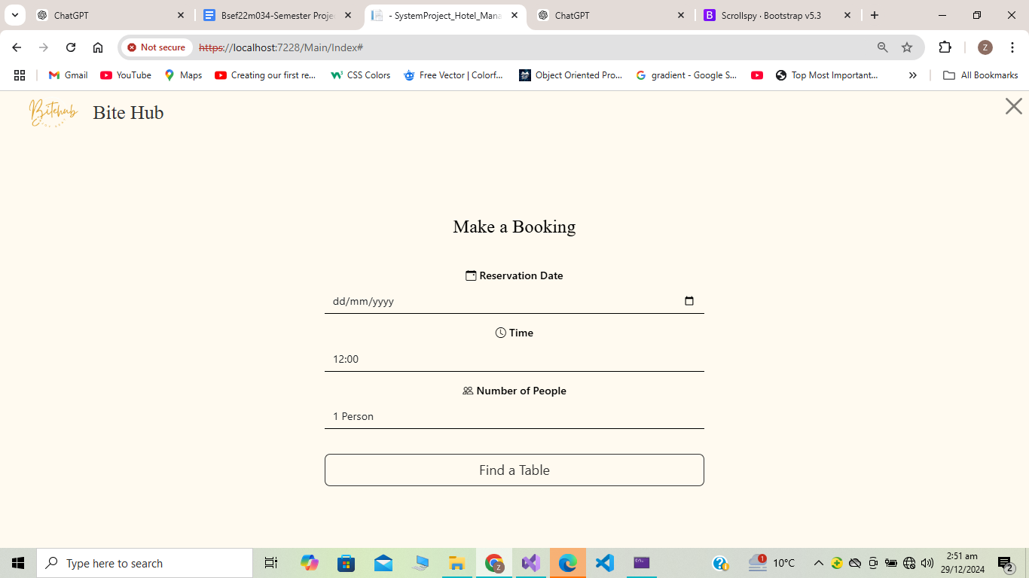
- Displays a reservation form using a Razor partial view (<partial name="_PR" model="@Model">).

Offcanvas for Navigation:
Purpose: Provides a compact menu for mobile users.
Components:
- Includes links to the home page, menu, gallery, about, contact, and careers sections.
- Social media icons for Instagram and Facebook.

<main> Section:
Purpose: Acts as a placeholder for dynamic content.
Components:
- @RenderBody() injects content from other pages into this layout dynamically.

Footer Section (JavaScript)

The footer includes information about the restaurant's branding, operating hours, and social media links.
1 Footer Main:
- Columns:
  - Left Column: Displays the logo and restaurant name.
  - Middle Column: Lists operating hours for different services (Grand Café and Music & Kawali).
  - Right Column: Social media links for Instagram and Facebook.
3.2 Footer Bottom:
- Purpose: Contains copyright information and additional footer links.
- Components:
  - Links to policies like Cookies Policy, Privacy Policy, and Terms of Use.

Index View
- External Resources:
- Several font libraries are linked, such as Google Fonts (Cinzel, Luminari, Poppins) to style text, and Bootstrap Icons and Font Awesome to provide a variety of icons across the page.
  - Bootstrap is used for layout components like grids and the carousel.
  - Custom CSS is included to apply additional styles specific to this page

Main Section (Carousel)
- Purpose: The main section contains a Bootstrap carousel that displays a series of images. The carousel provides a visually appealing way to show images representing various aspects of the hotel, such as different events or dining options.
- Carousel Indicators: Circular buttons located beneath the carousel allow users to manually navigate through the images. Each indicator corresponds to one of the carousel items and gives users the ability to jump to a specific slide.
- Carousel Items: Each carousel item includes an image with a caption. The captions are large, bold text designed to grab attention and describe the content of the image, such as "Winter Terrace" or "Weekend Brunch."
- Control Buttons: Previous and next buttons allow users to navigate through the carousel manually. These controls are placed on the left and right sides of the carousel, making it easy to move between slides.

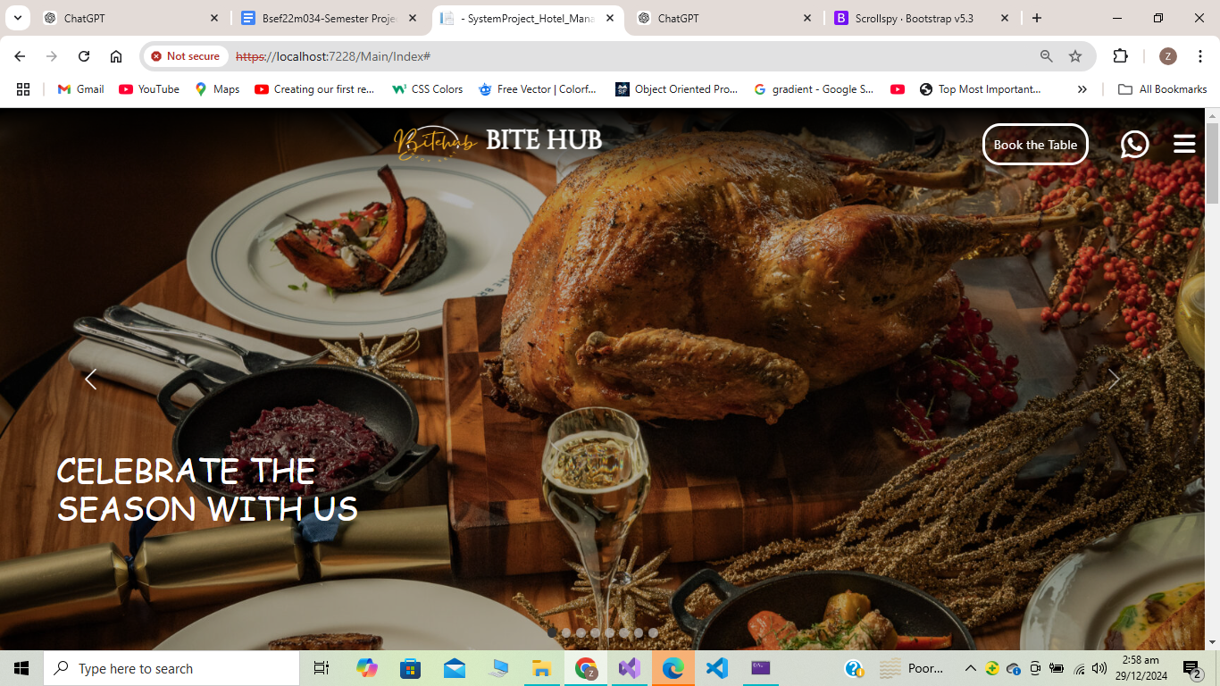
About Section
- Purpose: This section provides information about the hotel's offerings, such as deals, dining options, and reservations. It is styled as a centered block with links to different hotel services.
- Service Links:
  - Links such as "Deals", "Dining & Delivery", and "Reservation" are provided in a navigation-style format. These links are designed to stand out and allow users to quickly access specific services.
  - Each link is separated by a divider for a clean and organized layout.
- Placement: The section is placed below the carousel, offering information about the hotel's services and providing clickable links for more details.

After-Before Section(Cards Section)
- Purpose: This section is intended for additional content (labeled as "Cards" in the code) that may be added later, such as promotional cards or other interactive elements.
- Fetch data from <partial name="_courselSlider" model="@Model" ></partial>
- Placement: It appears after the About Section, but is currently empty apart from a placeholder text. This section can be expanded in the future to display content dynamically.

Explore Our Menu
Description:
- Purpose: This section introduces the menu and invites users to explore the restaurant's offerings.
- Left Column: Contains a textual description with an engaging heading, a brief introduction to the menu, and a call-to-action button to view the full menu.
  - The heading is styled with a dashed underline.
  - It highlights various cuisines (Desi, Chinese, junk food) and exclusive deals.
  - A button (View Full Menu) links to the ViewMenu action in the Menu controller.
- Right Column: Displays a video carousel showcasing various cooking scenes to visually represent the culinary process.
  - Uses Bootstrap's carousel component.
  - Contains multiple videos that autoplay and loop.
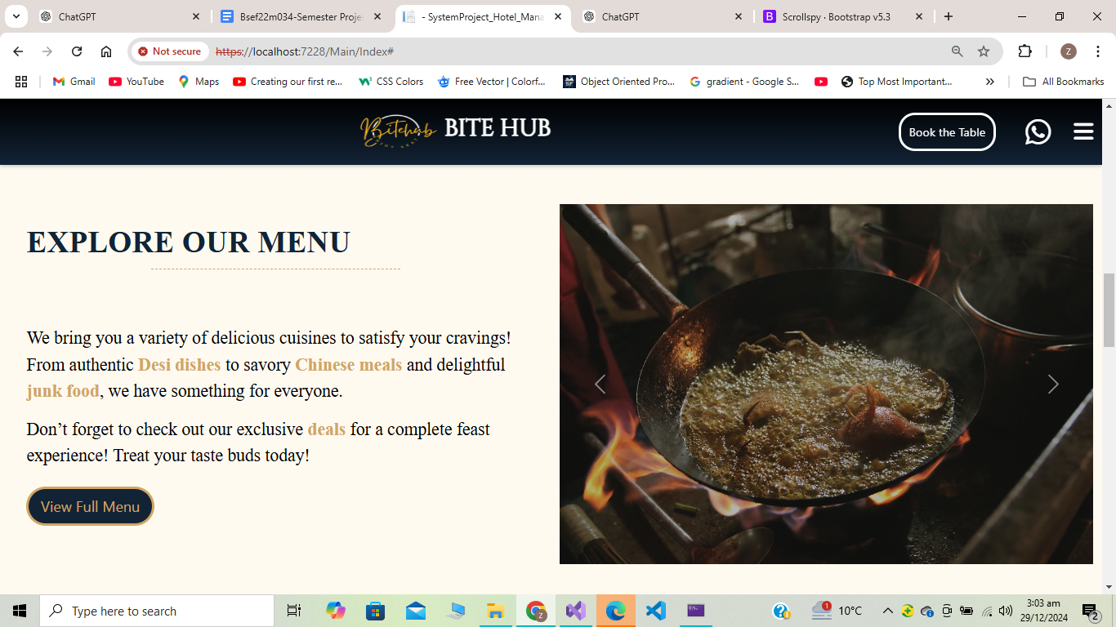
  - Navigation buttons are provided to slide between the videos.

Get in Touch
Description:
- Purpose: Encourages user interaction by inviting feedback or suggestions.
- Background: Uses a semi-transparent overlay on a background image for aesthetic appeal.
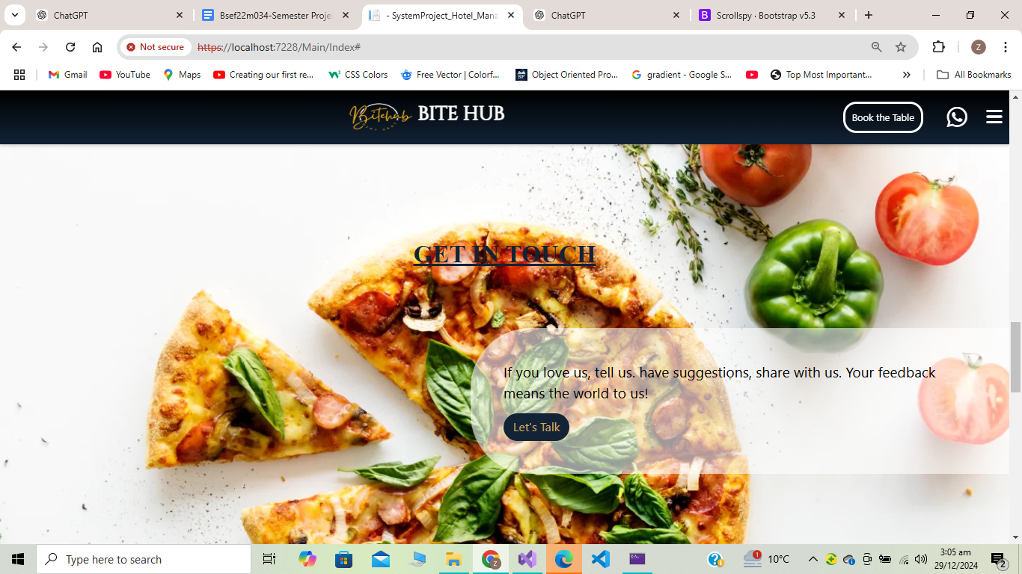
- Heading: Includes a centered and underlined heading styled in Arial.
- Content: Contains a brief message inviting users to share feedback and a call-to-action button (Let's Talk) linking to the contactUs action in the Menu controller.

Book the Table
Description:
- Purpose: Promotes table booking services and emphasizes the cozy, winter-themed dining ambiance.
- Right Column: Contains another Bootstrap carousel that showcases videos related to dining setup (e.g., terrace seating, table arrangements).
  - Similar structure to the first section's carousel but with different video content.
- Left Column: Text content highlighting the restaurant's winter terrace experience with cozy blankets and warm drinks.
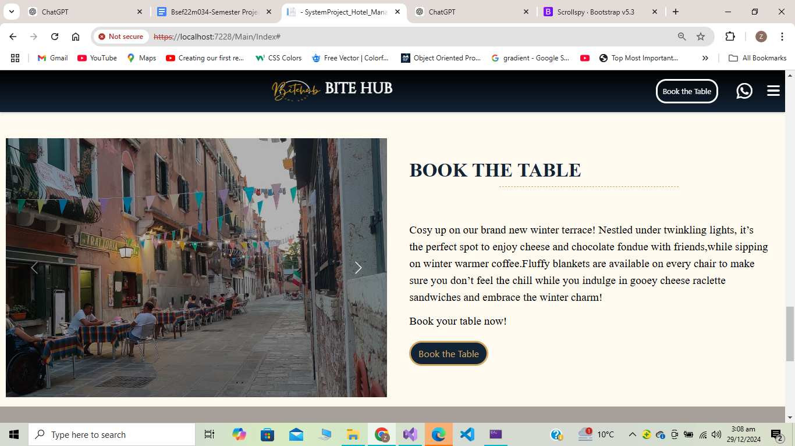
  - A Book the Table button is included, which triggers a Bootstrap offcanvas component for table reservations.

Sign Up Section
Description:
- Purpose: Encourages users to sign up for updates on deals and meals.
- Structure:
  - Left Side: Contains a heading and subheading styled to draw attention.
  - Right Side: Includes a button (Sign Up) linking to the menu section (identified by the #menu anchor).
- Styling: Uses a separate container (SignUp-container) and row to align content horizontally.

Scripts
- Bootstrap JS: The script includes the Bootstrap JavaScript bundle, which provides functionality for interactive components such as the carousel.
- Placement: The script is placed at the bottom of the document before the closing </body> tag to ensure that all elements are loaded before the script runs.

3.2 Menu Controller:
The MenuController in the SystemProject_Hotel_Management_ application is responsible for managing and rendering views related to the restaurant's menu, informational pages, and user interactions.

3.2.1 Action Methods:
ViewMenu
- Description: Retrieves a list of food items from the database and maps them to the FoodItemViewModel.
- Redirection: Returns the ViewMenu view, displaying the list of food items.
contactUs
- Description: Displays the "Contact Us" page.
- Redirection: Returns the contactUs view.
gallery
- Description: Displays the "Gallery" page.
- Redirection: Returns the gallery view.
AboutUs
- Description: Displays the "About Us" page.
- Redirection: Returns the AboutUs view.
RenderOrderModal
- Description: Retrieves details of a specific food item by ID and prepares data for a modal view. If the food item is not found, it returns a NotFound result.
- Redirection: Returns a partial view _OrderModal with the food item data.
Search
- Description: Filters food items based on the search query (name or description), maps the results to FoodItemViewModel, and prepares them for display.
- Redirection: Returns the Search view, displaying the filtered list of food items.

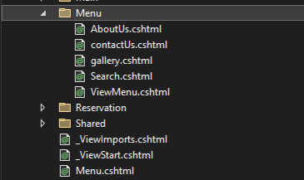
3.2.2 Views(For Menu Controller):

ViewMenu View

Navigation Bar:
- Purpose: Implements a scrollable navigation bar linking to sections like Burgers, Pizza, and more.
- Bootstrap Components: Utilizes nav and nav-pills for styling.

Header Section
Top Section:
Purpose: Displays a decorative banner image at the top of the page.
Middle Section:
Left Section: Highlights delivery options.
Center Section: Displays the restaurant's logo.
Right Section: Provides buttons for viewing the cart and signing up/registering.
Banner Image:
Purpose: Adds a full-width banner image beneath the navigation bar.

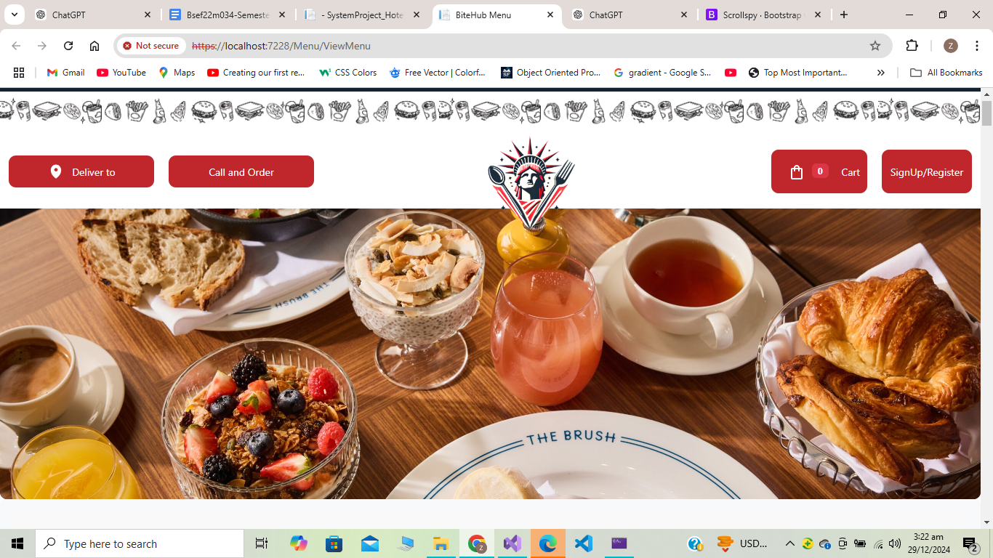
Menu Section with Scrollspy:
- Scrollspy Integration: The data-bs-spy attributes enable dynamic scrolling between sections like Burgers, Pizza, etc.
- Partial Views: Each section dynamically loads a partial view, filtered by category using CategoryID.

Search Bar:
- Purpose: Allows users to search for menu items.
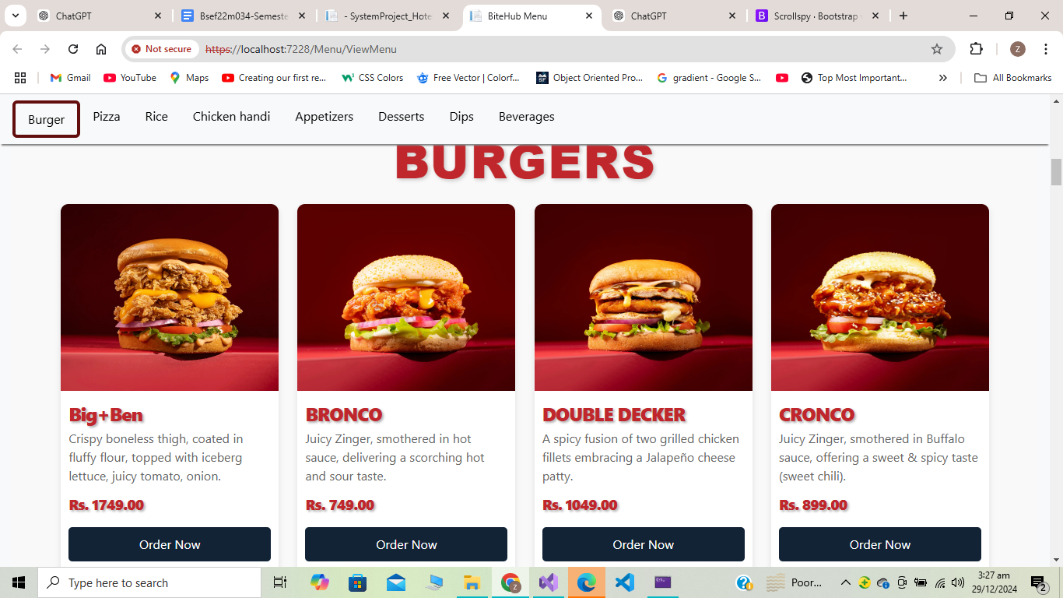
- Form Action: Redirects to the /Menu/Search endpoint for search processing.
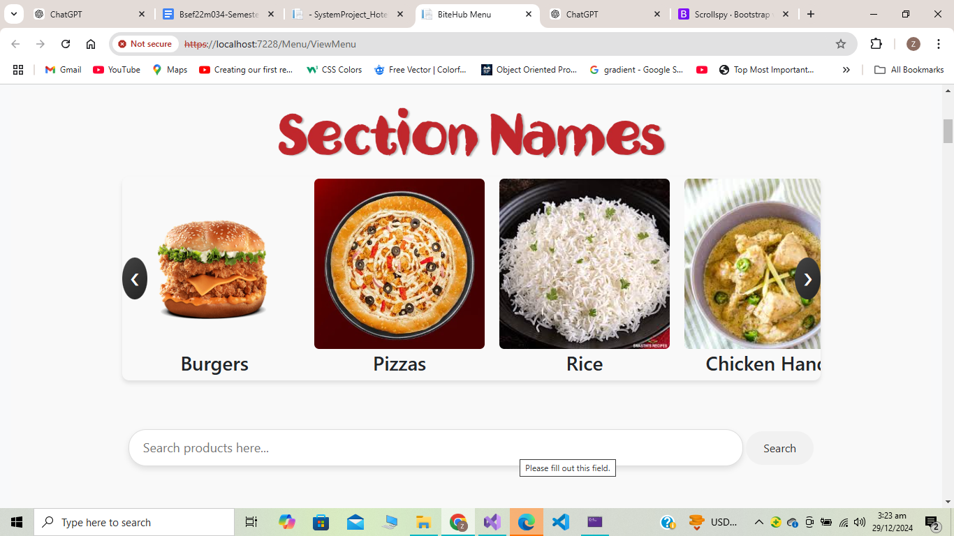

Footer Section:
Contact Info:
- Purpose: Provides contact details for the restaurant.
Quick Links
- Purpose: Offers links for easy navigation to menu categories.
Social Media Links:
- Purpose: Displays icons linking to social media platforms.

3.3 Cart Controller
The Cart Controller is a core component of the BiteHub application, responsible for handling all operations related to managing the user's cart and orders. This includes adding items to the cart, viewing the cart, removing items, clearing the cart, processing checkouts, and displaying order confirmations. It interacts with the database through the BiteHubDbContext to retrieve, update, and manage cart and order data.

3.3.1 Action Methods

AddToCart (POST)
This method allows a user to add a specific food item to their cart.
- Primary Purpose: To add a food item with the specified quantity to the cart.
- Behavior:
  - It first checks if the food item exists in the database.
  - Verifies if the user is logged in via session.
  - If no cart exists for the user, it creates a new cart.
  - Adds the item to the cart or updates the quantity if it already exists.
- Redirect: No redirection; it returns NoContent after successfully adding the item.

ViewCart (GET)
This method displays all items currently in the user's cart.
- Primary Purpose: To retrieve and show the cart contents to the user.
- Behavior:
  - Ensures the user is logged in.
  - Fetches cart items along with food item details.
  - Maps the data to a CartItemViewModel for rendering in the view.
- Redirect: Redirects to the login page if the user is not logged in.

ClearCart (GET)
This method removes all items from the user's cart.
- Primary Purpose: To clear the user's cart entirely.
- Behavior:
  - Verifies if the user is logged in.
  - Removes all CartItem records associated with the user's cart.
- Redirect: Redirects to the ViewCart page after clearing the cart.

RemoveFromCart (POST)
This method removes a specific item from the cart.
- Primary Purpose: To delete a specific item from the user's cart.
- Behavior:
  - Finds the cart item by its ID.
  - Removes the item from the database.
- Redirect: Redirects to the ViewCart page to reflect changes.

Checkout (GET)
This method displays a summary of the user's cart and prepares the checkout view.
- Primary Purpose: To provide an overview of the cart and calculate the total amount for checkout.
- Behavior:
  - Ensures the user is logged in.
  - Retrieves the cart and its items, mapping them to a CheckoutViewModel.
- Redirect:
  - Redirects to the login page if the user is not logged in.
  - Redirects to ViewCart if the cart is empty.

Checkout (POST)
This method processes the user's order during checkout.
- Primary Purpose: To finalize the order and save it in the database.
- Behavior:
  - Validates the checkout form data.
  - Creates a new Order and OrderItem records based on the cart data.
  - Clears the cart after successfully placing the order.
- Redirect: Redirects to the OrderConfirmation page after placing the order.

OrderConfirmation (GET)
This method displays the details of a completed order.
- Primary Purpose: To provide the user with a confirmation of their order.
- Behavior:
  - Fetches the order details, including user, items, and food information.
  - Maps the order data to an OrderDetailsViewModel for rendering.
- Redirect: None; it directly displays the order confirmation view.

3.3.2 Views(For Cart Controller):
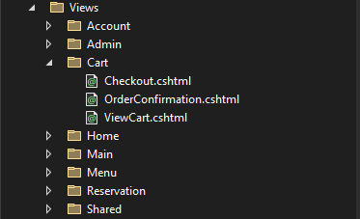

ViewCart View:

This code is an ASP.NET Razor View that renders a user interface for displaying and interacting with the contents of a shopping cart. It uses conditional logic, loops, and HTML forms to dynamically generate the cart's content based on the model passed to the view. Below is a breakdown of its functionality:
1. Overall Structure
- The body contains a div with a class of cart-container to group the cart-related elements.
- A footer is included at the bottom to display some additional information like copyright and links.
Empty Cart Message:
Purpose: To inform the user when the cart is empty.
Logic:
- Checks if the model (representing the cart items) has no items (Model.Count == 0).
- If the cart is empty, displays a message with a link to browse the menu.
Cart Table:
Purpose: Displays the list of items currently in the cart in tabular format.
Logic:
- Uses a foreach loop to iterate through the items in the model (cart items).
- Displays properties like:
  - FoodItemName: The name of the food item.
  - Quantity: The number of units of this item.
  - Price: Price per unit (formatted as currency with .ToString("C")).
  - Total: Total price for this item (calculated elsewhere and passed via the model).
- Includes an Action column:
  - Contains a form to remove the item from the cart using a POST request to the RemoveFromCart action method of the Cart controller.
  - Passes the item's ID as a route parameter.
Cart Summary:
Purpose: Displays the total price of all items in the cart.
Logic:
- Uses the Sum method to calculate the total price by summing the Total property of all cart items in the model.
- Formats the result as currency using .ToString("C").
Cart Actions:
Purpose: Provides two key actions for the user.
- Proceed to Checkout: Redirects the user to the Checkout action method in the Cart controller.
- Clear Cart: Redirects the user to the ClearCart action method in the Cart controller to remove all items from the cart.

OrderConfirmation View:

Overall Structure of the Page:The view is designed to display an order confirmation message. It utilizes Razor syntax (@Model) to dynamically render the user's order details based on the data passed to it.
Container and Title:The content is wrapped inside a div with the class container to provide styling and structure. The title of the page is displayed as "Order Confirmation."
Thank You Message and User Details:This section displays a personalized thank-you message to the user (@Model.UserName) and important details about their order, such as the OrderID, OrderDate (formatted as a full date and time), and the Status of the order.
Delivery Details:The delivery details are shown in a section with the class order-summary. It includes the shipping address (@Model.StreetAddress, @Model.City) and the user's phone number (@Model.PhoneNumber).
Total Amount:This section displays the total amount of the order (@Model.TotalAmount) formatted as currency.
Navigation Button:At the bottom, there's a button that redirects the user back to the home page. It uses asp-action and asp-controller attributes to generate a link to the Index action in the Main controller.

CheckOut View:

Page Structure and Purpose:The code represents a Checkout page where users can review their cart items, enter delivery details, and place an order.
Container and Title:The div with the class container holds the content of the checkout page. The page title "Checkout" is displayed using an <h2> tag.
Empty Cart Check:This block checks if the CartItems list is null or empty using Razor syntax.
- If true, it displays a message saying "Your cart is empty" with a link to navigate back to the cart page.
Cart Items Table:
If there are items in the cart, this block renders a table showing:

Item: The name of the food item (@item.FoodItemName).
Quantity: The number of items in the cart (@item.Quantity).
Price: The price of one unit of the item, formatted as currency (@item.Price.ToString("C")).
Total: The total price for the item, calculated as quantity × price, also formatted as currency (@item.Total.ToString("C")).
Total Amount Display:Displays the total amount for all items in the cart, calculated as the sum of all item totals (@Model.TotalAmount).
Checkout Form:This is the checkout form where the user provides delivery details:
- Street Address (StreetAddress)
- City (City)
- Phone Number (PhoneNumber)
The TotalAmount is sent as a hidden field to maintain the total order value.
The form submits to the Checkout action method using the POST method.
Footer Section:This section provides a footer with copyright information and links to the Privacy Policy and

3.4 Reservation Controller :
The ReservationController is responsible for handling table reservation-related functionalities in the hotel management system. It interacts with the database to manage available tables, make reservations, and display reservation confirmations. The controller ensures smooth user flow by checking table availability and managing user sessions.

3.4.1 Action Methods:

AvailableTables
Primary Purpose
The AvailableTables action retrieves all tables marked as "Available" from the database and displays them to the user.
Behavior
- Fetches a list of available tables from the Tables table in the database (Status == "Available").
- Passes the list to the view for rendering.
Redirect
Does not redirect. It directly renders the view showing the available tables.

ReserveTable (POST)
Primary Purpose
The ReserveTable action handles the reservation process for a specific table.

Behavior
- Check User Login:
  - It ensures the user is logged in by checking the UserId from the session.
  - If the user is not logged in, it redirects them to the registration page with a return URL or to the login page (commented out in the code).
- Verify Table Availability:
  - Checks if the table with the given tableId is still available (Status == "Available").
  - If not, an error message is stored in TempData, and the user is redirected back to the list of available tables.
- Create Reservation:
  - Creates a new Reservation1 object with details such as reservation date, time, party size, status, and user information.
  - A random reservation number is generated for tracking purposes.
- Update Table Status:
  - Marks the table as "Booked" and saves the changes to the database.
- Prepare Confirmation View:
  - Retrieves the user details and creates a ReservationConfirmationViewModel to pass reservation details to the view.

Redirect
- Redirects to the registration page if the user is not logged in.
- Redirects to AvailableTables with an error message if the table is unavailable.
- Renders the ReservationConfirmation view on successful reservation.

3.4.2 Views(For Reservation Controller)

AvailableTables View:
Container Section
The <div class="container"> wraps all content, providing structured spacing and alignment.
Error and Success Messages
- Displays an alert if TempData["Error"] exists, styled as a dismissible error message.
- Displays an alert if TempData["Success"] exists, styled as a dismissible success message.
Tables Section
- Table Headers: Defines columns for "Table Number," "Seats," "Status," and "Action."
- Table Rows: Iterates through the Model collection to dynamically create rows for each table.
Table Status and Badge
- A badge dynamically shows the table's status ("Available" or "Booked") using Bootstrap classes:
  - Green badge (bg-success) for "Available".
  - Red badge (bg-danger) for "Booked".
Action Buttons
- Reserve Button:
  - Displays only for tables with status "Available."
  - Includes a form that posts the tableId to the ReserveTable action.
- Disabled Button:
  - Displays for booked tables, styled as a non-interactive button.
This structure allows users to view and reserve available tables interactively while handling feedback like errors or success messages.

ReservationConfirmation View:

Page Setup
- The Razor view uses the ReservationConfirmationViewModel to display reservation details.
Reservation Details
- Displays user-friendly information about the reservation using the model properties:
  - Reservation Number
  - User Name
  - Reservation Date (formatted as "Month Day, Year").
  - Reservation Time
  - Party Size
  - Table Number
Button
- The "Back to Available Tables" button links to the AvailableTables action in the ReservationController.
- Styled as a prominent, rounded blue button with hover effects and slight scaling for user interactivity.
This page provides a user-friendly and visually appealing way to confirm and review reservation details.

3.5 Account Controller
The AccountController handles user authentication, registration, and account-related functionalities in the BiteHub application. It provides views and processes requests for user login, registration, password management, and logging out. The controller also distinguishes between admin and regular users to ensure proper redirection.

3.5.1 Action Methods

Login (GET)
Primary Purpose
- Displays the login page with an empty LoginViewModel.
Redirect
- No redirection occurs here; the login form is rendered.

Login (POST)
Primary Purpose
- Authenticates the user or admin based on their email and password.
Behavior
- Admin Login: Redirects to AdminDashboard if the email is "admin@bitehub.com" and password is "123".
- User Login:
  - Checks the credentials against the Users table in the database.
  - If valid, stores the UserId in the session.
  - Redirects to the provided returnUrl (if valid) or ViewMenu if no return URL is provided.
- If invalid, displays an error message.
Redirect
- Admins: Redirect to AdminDashboard.
- Users: Redirect to ViewMenu or returnUrl if provided.

AdminDashboard (GET)
Primary Purpose
- Displays the admin dashboard page.
Redirect
- None. Directly renders the view.

CustomerDashboard (GET)
Primary Purpose
- Displays the customer dashboard page (optional).
Redirect
- None. Directly renders the view.

Register (GET)
Primary Purpose
- Displays the registration page with an empty RegistrationViewModel.
Redirect
- None. Directly renders the registration form.

Register (POST)
Primary Purpose
- Handles user registration by creating a new user in the database.
Behavior
- Validates the form data and checks if the email already exists.
- If valid, saves the user in the database and stores the UserId in the session.
- Redirects to the AvailableTables page after successful registration.
- Displays a message if the email already exists or validation fails.
Redirect
- On success: Redirects to AvailableTables.

ForgotPassword (GET)
Primary Purpose
- Displays the forgot password page to the user.
Redirect
- None. Directly renders the forgot password form.

ForgotPassword (POST)
Primary Purpose
- Allows users to reset their password by providing their email and a new password.
Behavior
- Validates the form and ensures the new password matches the confirmation password.
- Updates the password in the database for the specified user.
- Displays a message if the user is not found or if the passwords don't match.
Redirect
- On success: Redirects to the ViewMenu page.

Logout
Primary Purpose
- Logs out the user by clearing the session data.
Redirect
- Redirects to the Login page after clearing the session.

3.5.2 Views(For Account Controller):

Login View:
Login Page Structure
The Login Page provides a simple and user-friendly interface for users to log in to their BiteHub account.
Key Sections
Logo Container
Displays the BiteHub logo using an image located at /images/B__3_-removebg-preview.png.
Page Header
Welcomes the user with a heading (Welcome to BiteHub) and a subtitle encouraging login.
Error Message Display
If ViewBag.Message is not null, an error message (e.g., invalid credentials) is displayed in red text above the form.
Login Form
Includes:
- Hidden Field: Captures the return URL if provided (returnUrl).
- Email Field: Allows the user to input their email (required).
- Password Field: Accepts the user’s password (required).
Both fields are styled with form-control for a consistent look.
Login Button
A button styled as btn-login submits the form to process the login.
Registration and Forgot Password Links
- Redirect to the Register page for users who don’t have an account.
- Redirect to the Forgot Password page for password recovery assistance.

Register View:
Register Page Structure
The Register Page provides an intuitive form for new users to create an account on BiteHub.
Key Sections
Logo Container
Displays the BiteHub logo using an image located at /images/B__3_-removebg-preview.png.
Page Header and Subtitle
Welcomes users with a heading (Create Your BiteHub Account) and a subtitle encouraging them to join the community.
Error Message Display
If ViewBag.Message is not null, any validation error or duplicate email notification is displayed in red text above the form.
Registration Form
Includes:
- Name Field: Collects the user's full name (required).
- Email Field: Collects the user's email address (required).
- Password Field: Accepts a password input with a placeholder encouraging a strong password (required).
- Role Dropdown: Allows the user to select a role: Admin or Customer.
Register Button
Styled as btn-register, it submits the form for registration processing.
Login Redirect Link
Provides a link to redirect users to the Login Page if they already have an account.

ForgotPassword View:
Forgot Password Page
Page Header
The header ("Reset Your Password") clearly indicates the purpose of the page.
Error Message Display
If ViewBag.Message contains an error or validation message, it is displayed prominently in red text above the form.
Password Reset Form
- Email Field:
Collects the user’s email address, ensuring that the reset request is tied to a registered account.
- New Password Field:
Allows the user to input their new password.
- Confirm Password Field:
Ensures the user re-enters the password correctly for validation.
Reset Button
The Reset Password button, styled as btn-reset, submits the form for processing.

AdminDashboard View:
Header and Welcome Message
The page header ("Admin Dashboard") and welcome message ("Welcome, Admin!") indicate the admin's control center.
Navigation Options
- Manage Product:
Links to a page where the admin can add, update, or delete products.
- View Orders:
Directs to a section for reviewing customer orders.
- Manage Users:
Allows the admin to oversee user accounts, including editing or deactivating users.
- View and Edit Table Information:
Provides an interface to view or modify table details for reservations.
- View Reservations:
Displays a list of reservations for management or review.
- View Reports:
Gives access to detailed reports and analytics related to the platform's operations.

3.6 Admin Controller
The AdminController is responsible for managing administrative tasks in the BiteHub system. It provides action methods for viewing and managing orders, users, products, tables, and reservations. It also includes functionalities for generating reports.

3.6.1 Action Methods:

ViewOrders
- Primary Purpose: Retrieves all orders from the database and displays them, including user details, order dates, amounts, and statuses.
- Redirects: Renders the ViewOrders view with a list of orders.

ManageUsers
- Primary Purpose: Retrieves all users from the database and displays them for management (viewing, editing, deleting).
- Redirects: Renders the ManageUsers view with the list of users.

EditUser (GET)
- Primary Purpose: Fetches details of a specific user to edit their information.
- Redirects: Renders the EditUser view pre-filled with the user's current data.

EditUser (POST)
- Primary Purpose: Updates the user's details in the database after validation.
- Redirects: Redirects to the ManageUsers view after successful editing.

DeleteUser (GET)
- Primary Purpose: Retrieves the user's details to confirm deletion.
- Redirects: Renders the DeleteUser view with user details.

DeleteUserConfirmed (POST)
- Primary Purpose: Deletes the user from the database.
- Redirects: Redirects to the ManageUsers view after deletion.

ViewReports
- Primary Purpose: Generates and displays reports dynamically based on orders and other data.
- Redirects: Renders the ViewReports view with a list of reports.

ManageProduct
- Primary Purpose: Retrieves all products (food items) from the database for management.
- Redirects: Renders the ManageProduct view with the product list.

EditProduct (GET)
- Primary Purpose: Fetches details of a specific product to edit its information.
- Redirects: Renders the EditProduct view pre-filled with the product's current data.

EditProduct (POST)
- Primary Purpose: Updates the product details in the database after validation.
- Redirects: Redirects to the ManageProduct view after successful editing.

DeleteProduct (GET)
- Primary Purpose: Retrieves the product's details to confirm deletion.
- Redirects: Renders the DeleteProduct view with product details.

DeleteConfirmed (POST)
- Primary Purpose: Deletes the product from the database.
- Redirects: Redirects to the ManageProduct view after deletion.

AddProduct (GET)
- Primary Purpose: Prepares the form for adding a new product, including category selection.
- Redirects: Renders the AddProduct view.

AddProduct (POST)
- Primary Purpose: Adds a new product to the database after validation.
- Redirects: Redirects to the ManageProduct view after successful addition.

EditTables
- Primary Purpose: Retrieves all tables for management.
- Redirects: Renders the EditTables view with the table list.

EditTable (GET)
- Primary Purpose: Fetches details of a specific table for editing.
- Redirects: Renders the EditTable view pre-filled with the table's current data.

EditTable (POST)
- Primary Purpose: Updates the table details in the database after validation.
- Redirects: Redirects to the EditTables view after successful editing.

ViewReservation
- Primary Purpose: Retrieves all reservations from the database with related table and user details.
- Redirects: Renders the ViewReservation view with the reservation list.

CancelReservation
- Primary Purpose: Cancels a reservation and updates the associated table's status to "Available."
- Redirects: Redirects to the ViewReservation view after successful cancellation.

3.6.2 Views(For Admin Controller):
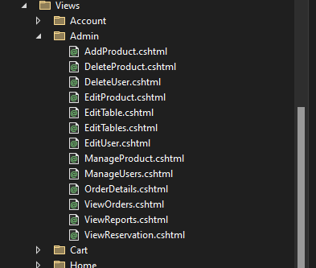

AddProduct View:
1. Form Structure
- Purpose: To allow admins to add a new product to the database.
- Action: The form posts data to the AddProduct action method in the controller using the POST method.

2. ASP.NET Tag Helpers
- asp-for: Automatically binds the form fields to the respective properties in the model (e.g., Name, Price, Description, etc.).
- asp-validation-for: Displays validation error messages for the corresponding fields.

3. Category Dropdown
- Binding: Uses ViewData["Categories"] to populate the dropdown options dynamically.
- Dynamic Data: Each option is rendered based on the list of categories passed from the controller (SelectList).

4. Bootstrap Integration
- CSS Classes: Bootstrap classes (e.g., form-control, form-label, btn btn-success) are used to ensure a responsive and visually appealing design.

5. Validation
- Client-Side Validation: Automatically handled by ASP.NET Core when validation attributes are added to the model.
- Error Display: Validation errors are shown using asp-validation-for with text-danger styling.

6. Picture URL
- Purpose: Allows adding an image link to represent the product visually on the frontend.

7. Scripts
- Bootstrap Bundle: Includes JavaScript required for Bootstrap components.

DeleteProduct View:
1. Purpose of the Page
- Functionality: Confirms the deletion of a product by displaying its details and providing the user with the option to proceed or cancel.
- Action: Posts the confirmation to the DeleteProduct action method.

2. Displaying Product Details
- Dynamic Data:
  - The product's Name, Price, and Description are displayed using the @Model object.
  - An image is conditionally shown if the PictureURL property is not empty, using an <img> tag.

3. Delete Form
- Hidden Field:
  - Includes a hidden field <input> to pass the product's ID back to the controller securely.
- Post Method: Uses the POST method to avoid accidental deletion through URL manipulation.

4. Cancel Button
- Action Link:
  - The Cancel button redirects to the ManageProduct page using @Url.Action("ManageProduct").

5. Styling
- Bootstrap Buttons:
  - btn-danger: Styled for the "Delete" button to indicate a destructive action.
  - btn-secondary: Styled for the "Cancel" button to indicate a neutral action.

6. Optional Enhancements
- Partial View: This confirmation block can be rendered as a partial view to reuse it across various delete scenarios.
- Client-Side Confirmation: A JavaScript confirmation box could be added for an additional confirmation step before submitting the form.

DeleteUser View:
1. Purpose of the Page
- Functionality: This page is used to confirm the deletion of a user by displaying their details and offering the option to delete or cancel.

2. Displaying User Details
- Dynamic Data:
  - The user's Name and Email are displayed using the @Model object. This data is passed from the controller to show details of the user being deleted.

3. Delete Form
- Hidden Field:
  - A hidden input field <input type="hidden" asp-for="UserId" /> is used to pass the user’s ID to the DeleteUserConfirmed action when the form is submitted.

4. Action Buttons
- Delete Button:
  - A "Delete" button with the btn-danger Bootstrap class is used to style the button in red to signify a dangerous action.
- Cancel Button:
  - A "Cancel" button, which is a link styled with the btn-secondary class, redirects the user to the ManageUsers page without performing any action.

5. Form Submission
- POST Method: The form uses the POST method to submit the request to delete the user, ensuring that the deletion only occurs when the user explicitly confirms the action.

6. Bootstrap Classes for Styling
- btn-danger: A Bootstrap class used to style the "Delete" button in a red color, signifying the importance of the action.
- btn-secondary: A Bootstrap class used to style the "Cancel" button in a neutral color.

7. Optional Enhancements
- Client-Side Confirmation: Before form submission, you could add a JavaScript confirmation dialog to ensure the user intends to perform the deletion.
- Partial View: This confirmation form could be refactored into a partial view for reuse in other parts of the application.

EditProduct View:

1. Purpose of the Page
- Functionality: This page is used to edit an existing product’s details. It includes fields for updating the product name, price, description, category, and picture URL.

2. Form Elements
- Product Name:
  - An input field that binds to the Name property of the model. It is displayed using asp-for="Name" and includes a validation message if the field is invalid (asp-validation-for="Name").
- Price:
  - The price input is a number field with a step of 0.01 to allow for decimal values, such as prices like 19.99. Validation for price errors is shown in a similar manner to the name field.
- Description:
  - A textarea for entering the product description, bound to the Description property of the model. Like the others, it also has a validation span (asp-validation-for="Description").

3. Category Field
- Hidden CategoryID:
  - A hidden input field is used for the CategoryID, which binds to the model but is not editable in this form. It is displayed as a read-only value using a div that is populated with @Model.CategoryID. This ensures that the product's category is displayed but not changed during editing.

4. Picture URL
- Picture URL Input:
  - A standard text input for the product's image URL, bound to PictureURL. A validation message is shown if there’s an issue with this field, like an invalid URL.

5. Submit Button
- Save Changes:
  - A submit button that allows the user to save the changes made to the product.

6. Bootstrap Styling
- Form Layout:
  - Each input field, text area, and label is styled using Bootstrap's form-control class to ensure the form is visually appealing and user-friendly.
  - The btn btn-primary class is used to style the "Save Changes" button, giving it a primary button look.

7. Model Binding and Validation
- The form uses Model Binding with the asp-for attributes to automatically bind the form fields to the corresponding model properties (e.g., Name, Price, Description, CategoryID, and PictureURL).
- Validation: The asp-validation-for tags are used to display any validation errors for each field if the model fails validation when the form is submitted.

8. Notes for Enhancements
- Category Field Editing: If needed, consider allowing the category to be editable instead of displaying it as a readonly field.
- Confirmation of Changes: It could be beneficial to add a confirmation message or a review step before saving changes to provide an additional layer of user interaction.
- Client-side Validation: Additional client-side validation can be added to improve user experience by preventing form submission until the fields are correctly filled out.

EditTable View:
Purpose of the Page
This page is for editing the details of an existing table in the restaurant management system. It allows users (likely administrators) to modify information such as table number, the number of seats, and status.

TempData for Error and Success Messages
- TempData["Error"]:
If an error occurs (e.g., invalid input or failure to save), the error message is displayed using an alert box with a red background (alert-danger class).
- TempData["Success"]:
If the operation is successful (e.g., table details updated successfully), a success message is shown in a green alert box (alert-success).

Form Elements
- Table ID:
The Id field is hidden (<input type="hidden" asp-for="Id" />) and is bound to the model's Id property. This ensures the system knows which table is being edited when the form is submitted.
- Table Number:
The TableNumber field allows the user to input or modify the table number. It is bound to the TableNumber property of the model using asp-for="TableNumber". If there is any validation error, it will be displayed below the field (asp-validation-for="TableNumber").
- Seats:
The Seats field allows the user to specify how many seats the table can accommodate. Similar to the table number, this field is bound to the Seats property, with validation errors displayed underneath.
- Status:
The Status field is for indicating the current state of the table (e.g., available, occupied, reserved). Like the others, it is bound to the Status property and includes validation messages if there are any issues.

Submit Button
The submit button (Save Changes) allows the user to submit the form and save the changes made to the table details. It is styled with btn btn-primary btn-block to give it a primary button look and make it full width for better user experience.

Form Structure
- Form Class:
The form-container class is applied to the <form> element, which you can style with custom CSS to control the layout, padding, or margins of the form.
- Form Group:
Each input field is wrapped inside a form-group div to ensure proper layout and spacing.
- Input Fields:
The fields use the form-control form-input classes to apply Bootstrap styles and custom classes (if any).

Validation
- Model Binding:
The asp-for attributes bind each input field to the respective model property (TableNumber, Seats, Status). If the model fails validation (e.g., empty fields or invalid data), error messages will be displayed below each field.
- Validation Messages:
The asp-validation-for tags show error messages associated with each field.

Notes for Enhancements
- Dropdown for Status:
If the Status field is meant to be a limited set of values (e.g., "Available", "Occupied", "Reserved"), consider changing it to a dropdown list instead of a text input for better user experience.
- Client-side Validation:
Additional client-side validation could be implemented to ensure users are not able to submit the form with empty fields or invalid data (though it appears server-side validation is already in place).
- Custom Error Handling:
Depending on your application's needs, you might want to handle specific errors (e.g., a table number that already exists) more dynamically with custom messages.

ViewReservation View:
Page Title and Container
The page has a title "View Reservations" that is centered using the text-center class. The entire content is wrapped inside a <div> with the container class, which ensures the layout is responsive and properly padded.

Error Message Handling
- TempData["Error"]:
If there is an error message stored in TempData["Error"], it will be displayed in an alert box with a red background (alert-danger class). This could be used for error notifications such as unsuccessful cancellation or other issues related to reservations.

Table Structure
The table is used to display the list of reservations, with the following columns:
- Reservation Number: Displays the unique ID of the reservation.
- User Name: Displays the name of the user who made the reservation, accessed through @reservation.User.Name.
- Table Number: Shows the table number associated with the reservation, accessed through @reservation.Table.TableNumber.
- Seats: Displays the party size (@reservation.PartySize), which is the number of seats reserved.
- Status: Shows the status of the reservation (e.g., "Pending", "Confirmed", "Cancelled").
- Reservation Date: The date of the reservation, formatted to display in the format "Month Day, Year" (e.g., "January 01, 2024").
- Reservation Time: Displays the time of the reservation.
- Actions: Contains actions that can be performed on the reservation (such as canceling the reservation).

Displaying Data with a Foreach Loop
The data is dynamically generated using a foreach loop, iterating over the Model collection, which is expected to contain the reservations. For each reservation, a row is added to the table with the respective details pulled from the reservation object.

Cancel Reservation Action
- Condition for Cancellation:
A check is performed to ensure that the reservation status is not "Cancelled" before allowing the cancellation. If the status is not "Cancelled", a form is rendered that submits a POST request to the CancelReservation action in the Admin controller.
- Confirmation Dialog:
The cancellation form has an onsubmit event that triggers a JavaScript confirmation dialog, asking the user to confirm if they are sure they want to cancel the reservation. If the user cancels the action, the form will not be submitted.
- Hidden Input for Reservation ID:
The reservationId is passed to the backend as a hidden input, ensuring the server knows which reservation to cancel.
- Cancel Button:
The "Cancel" button is styled with the btn btn-danger class to indicate that it performs a destructive action (cancelling a reservation).

THE END

